**Case Study**

**Nimish Birla**

**Batch-5 (Room No-008)**

**Problem Statement-** Implementing a Seamless CI/CD Workflow for a Spring Boot Application using Azure Boards, Azure, Git, Maven, Docker, GitHub, GitHub Actions.

**Background**: Streamline Solutions Inc. is a dynamic technology company specializing in cutting-edge software solutions. The company is developing a sophisticated Java Spring Boot application designed to revolutionize user experience. To ensure a swift and error-free software deployment process, Streamline Solutions is seeking to establish an efficient Continuous Integration and Continuous Deployment (CI/CD) workflow.

Project Management Setup: - Laptop, Azure Login, GitHub Login

Azure VM Configuration:

Creating a virtual machine-

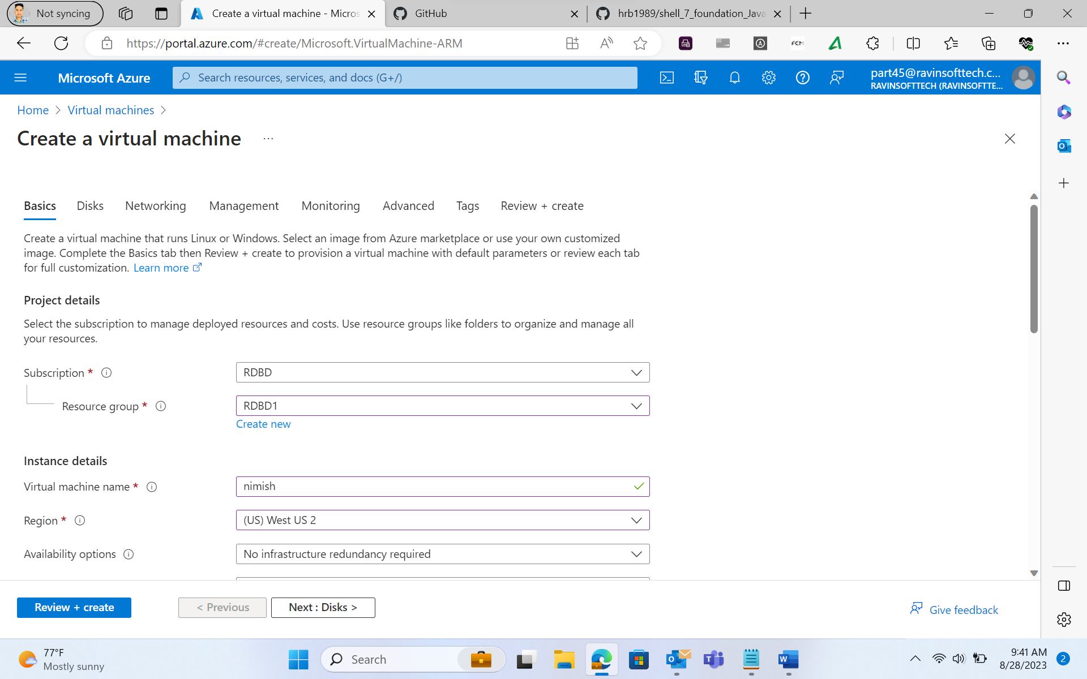

Enter username and password for the virtual machine-

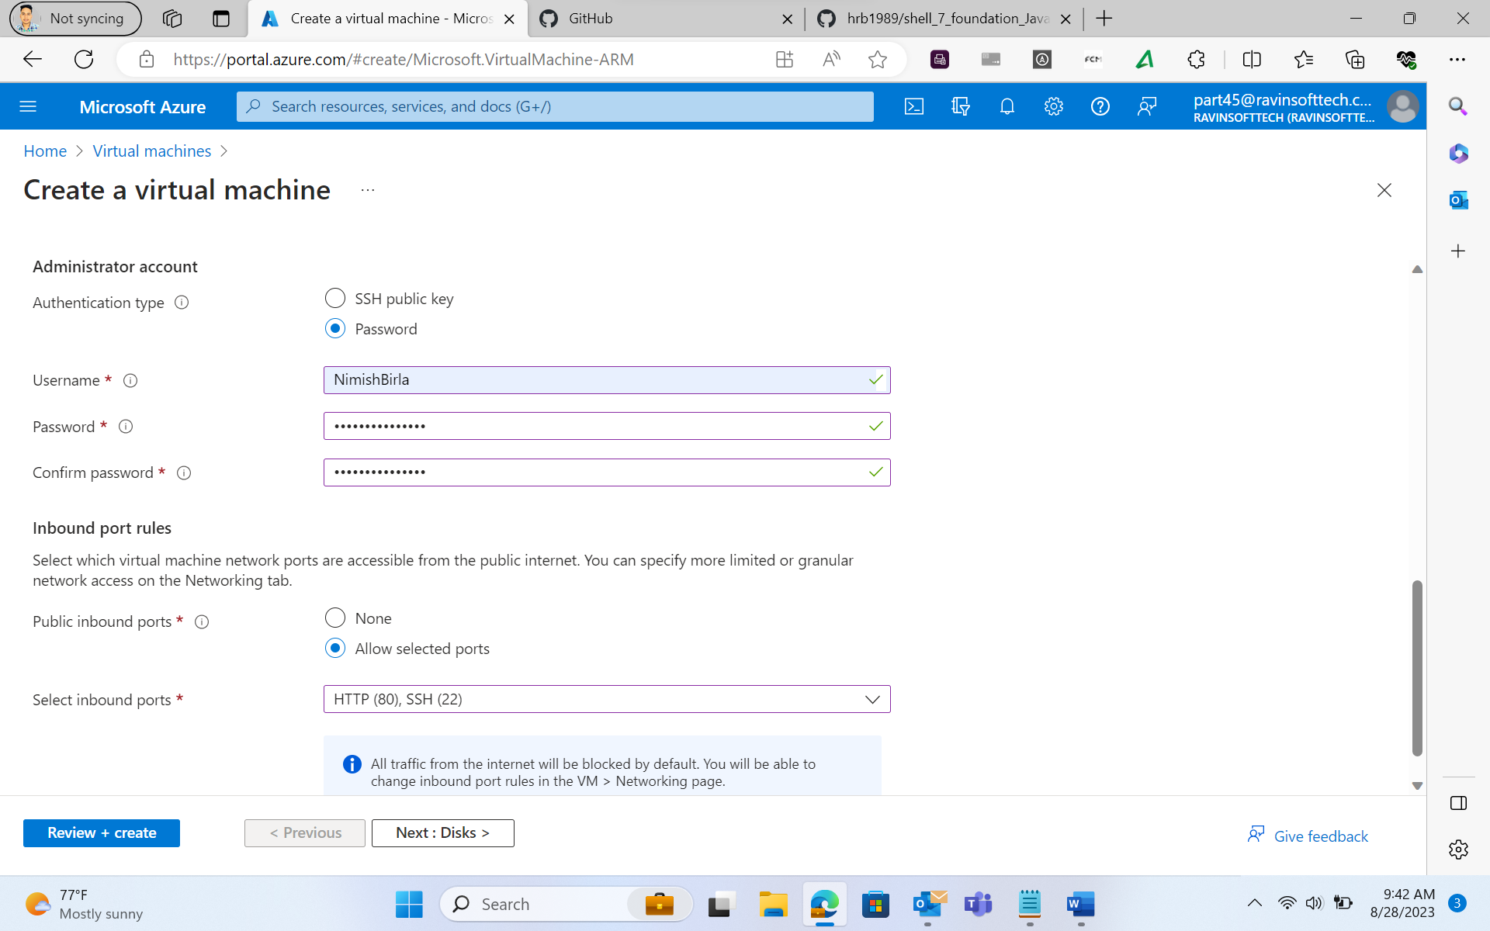

Entering the disk type and storage for the VM-

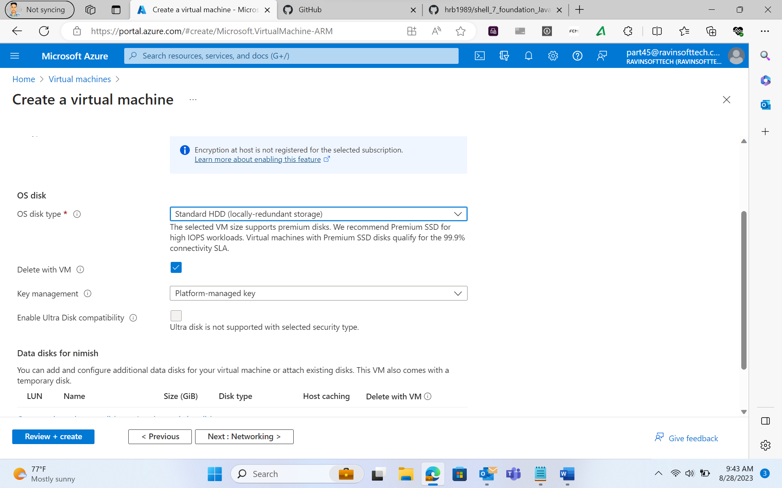

Validation passed-

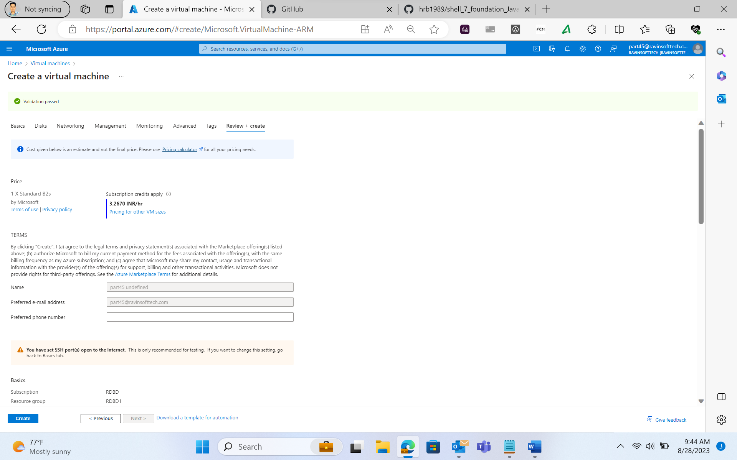

Completion of Deployment-

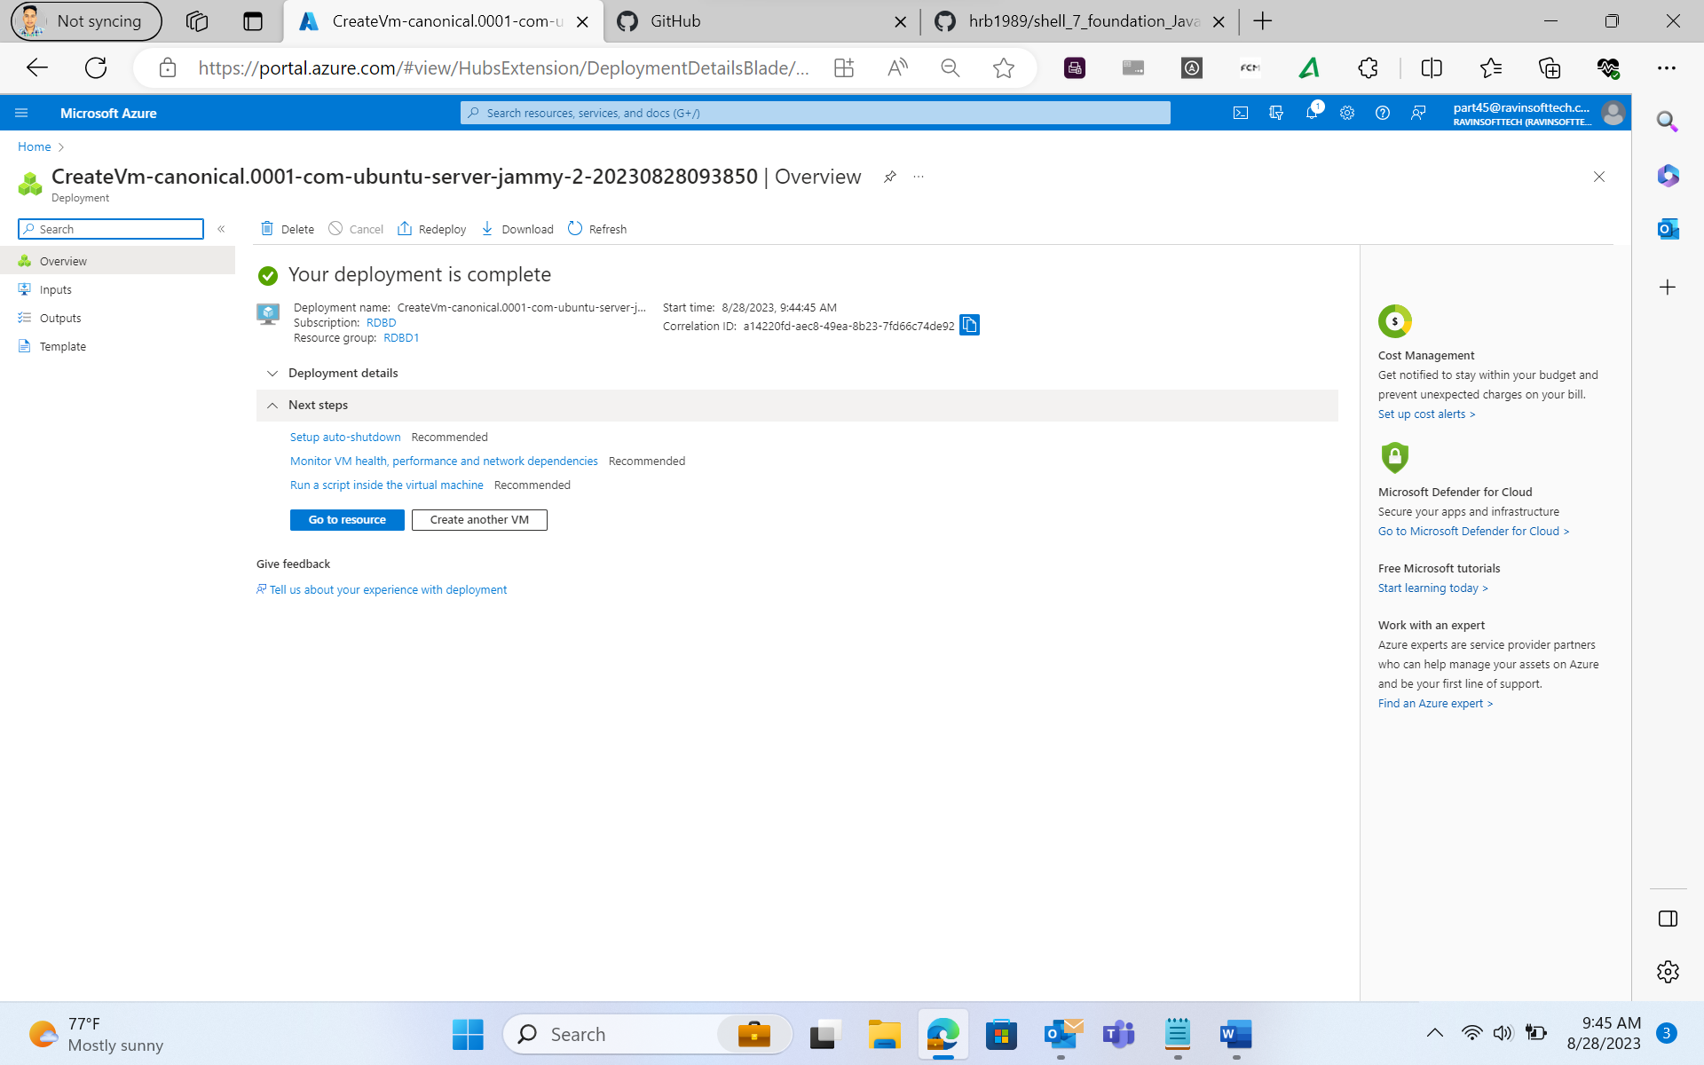

Overview of the Virtual Machine-

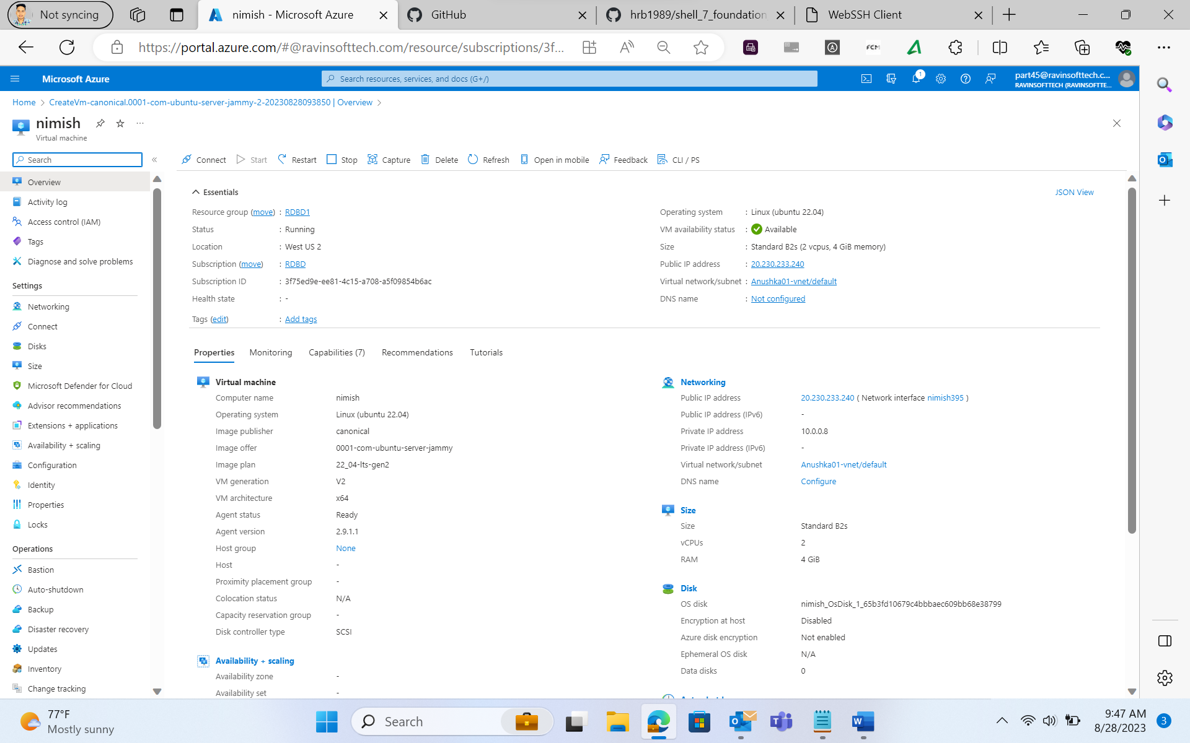

Maven-Based Build Process: While installing maven we encountered our machine have JAVA11 and we require JAVA17.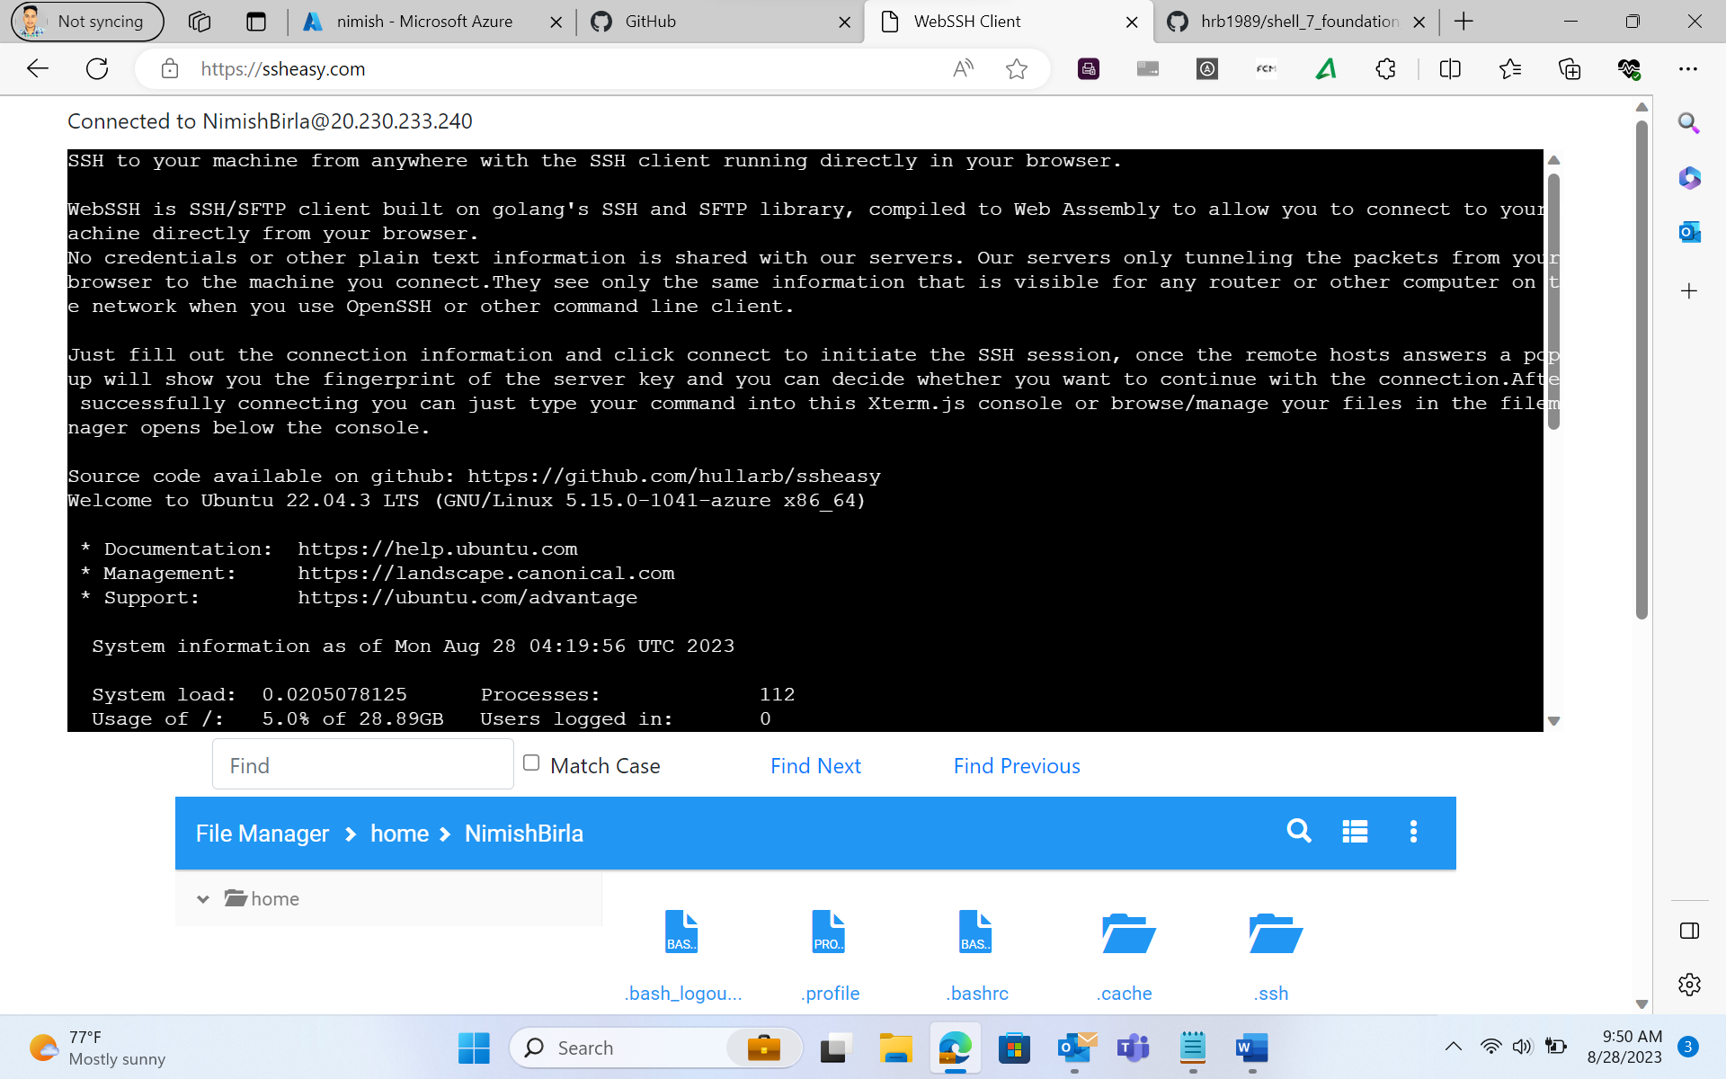

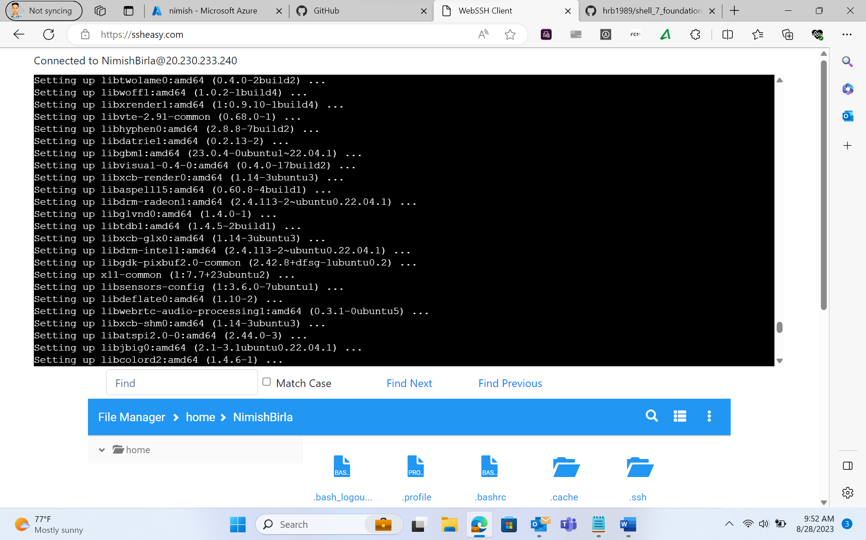

Updating the machine apt packages-

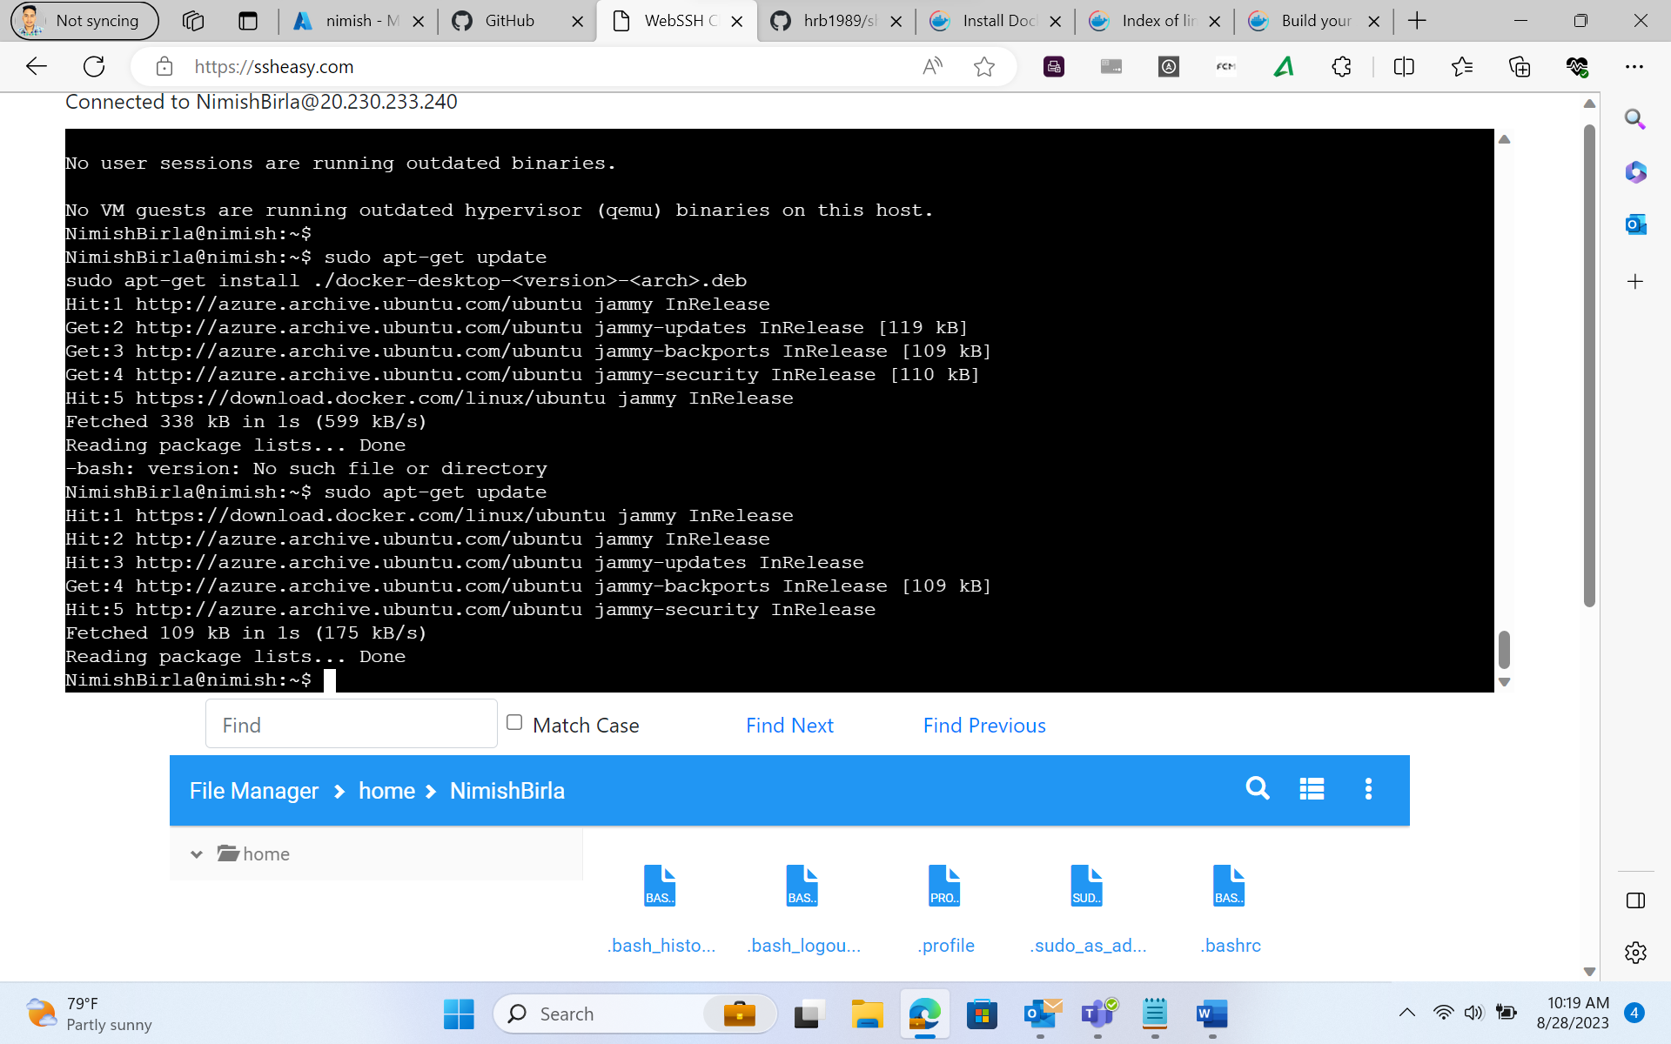

Installing the docker software-

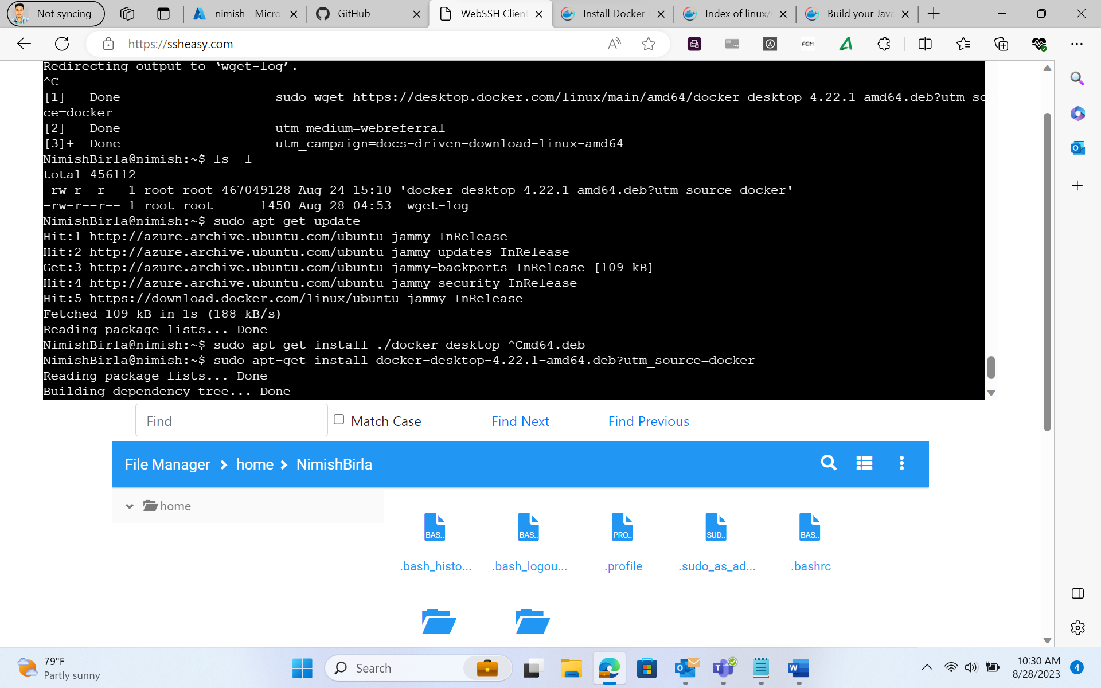

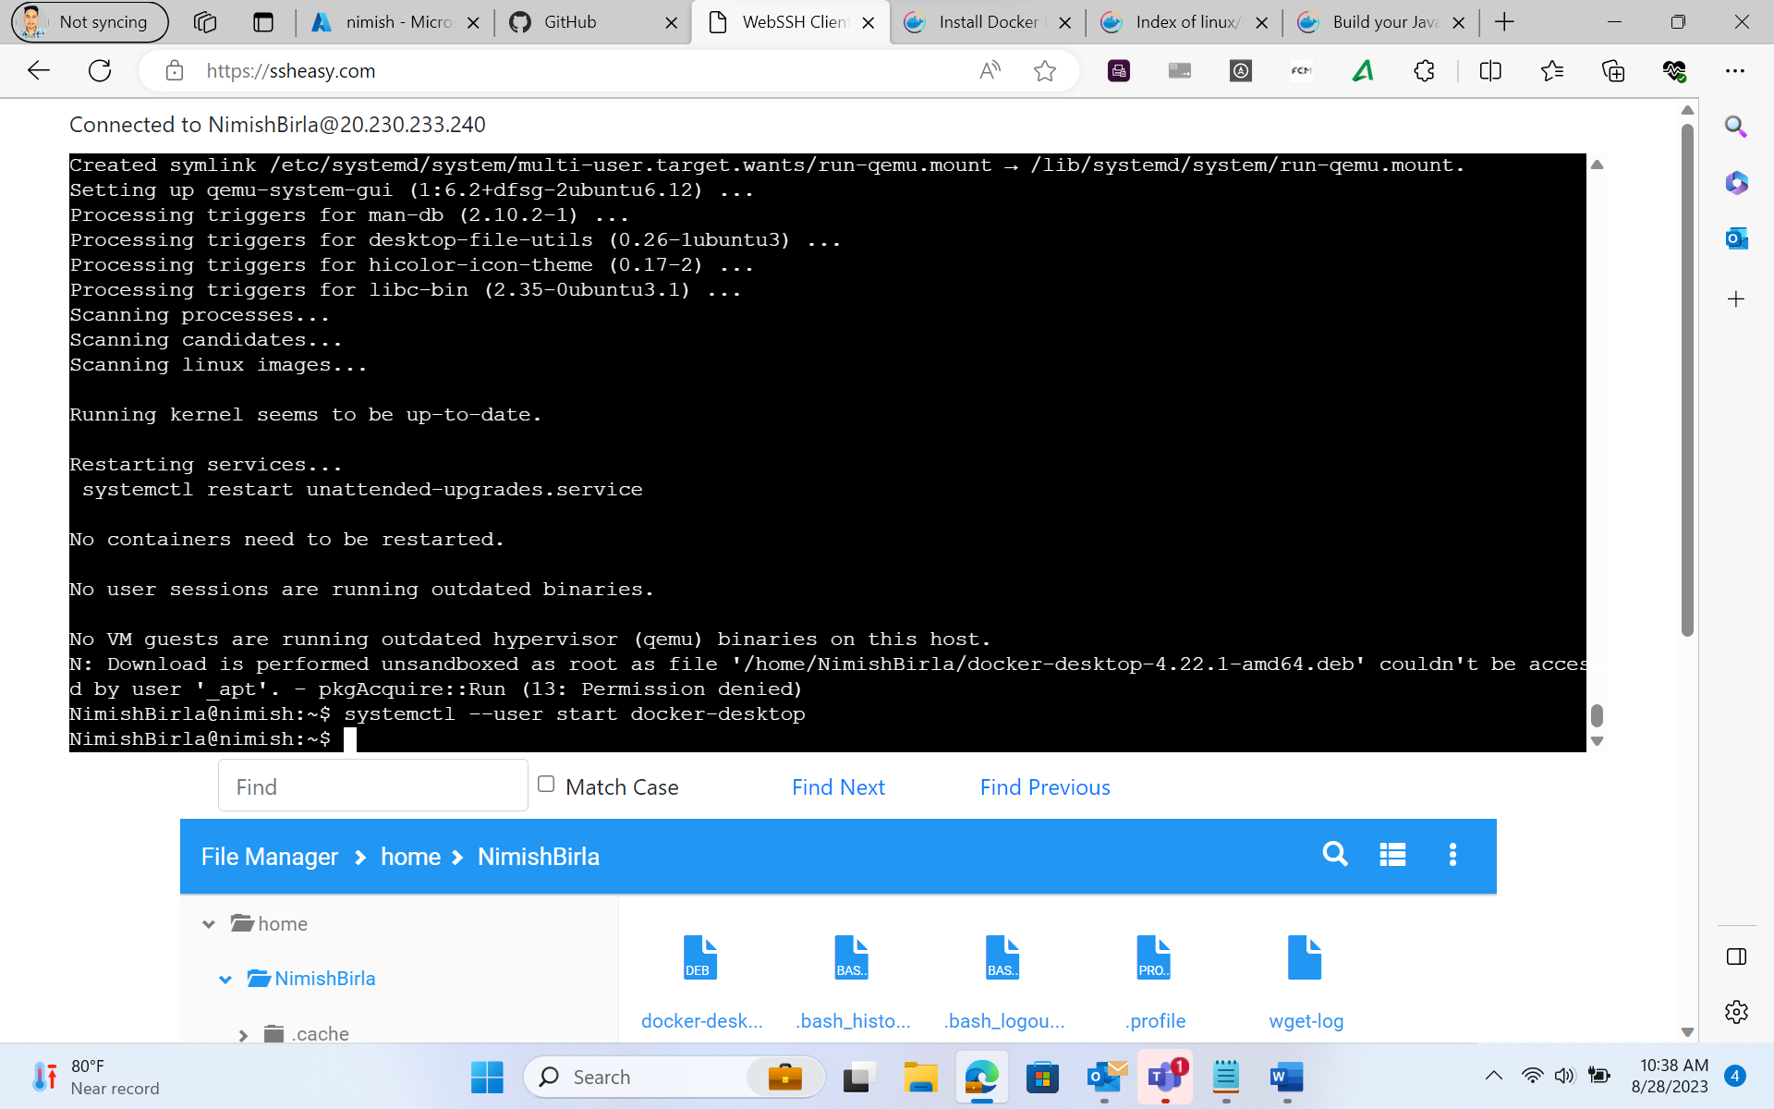

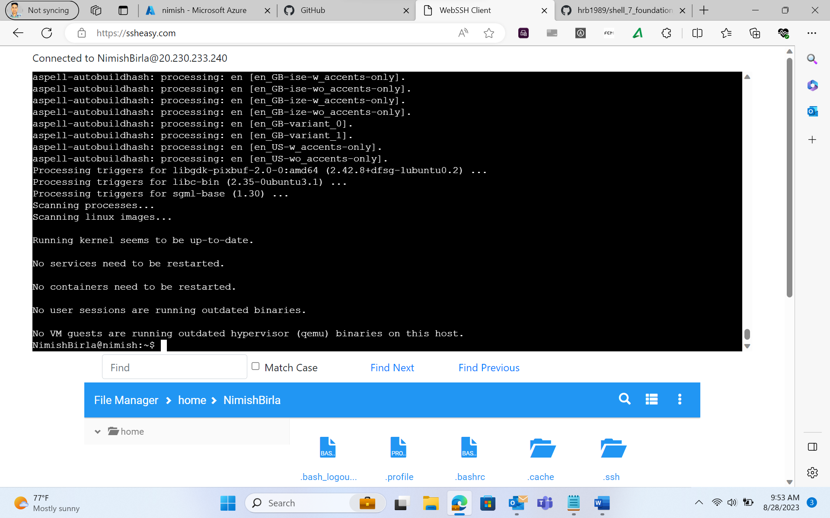

Docker Containerization:

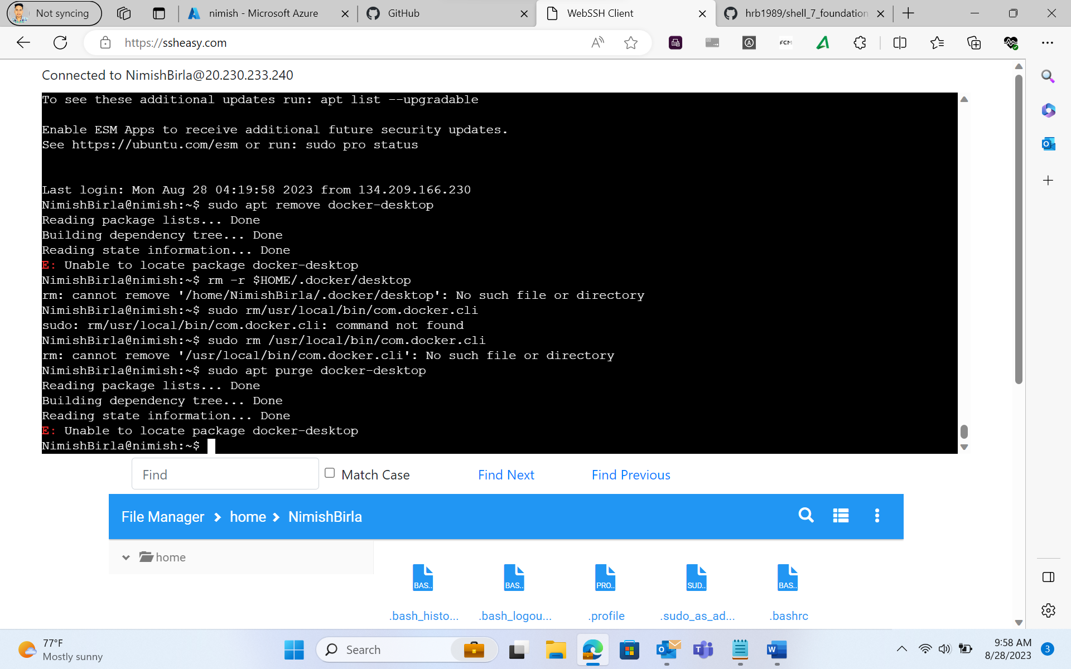

Showing the docker version-

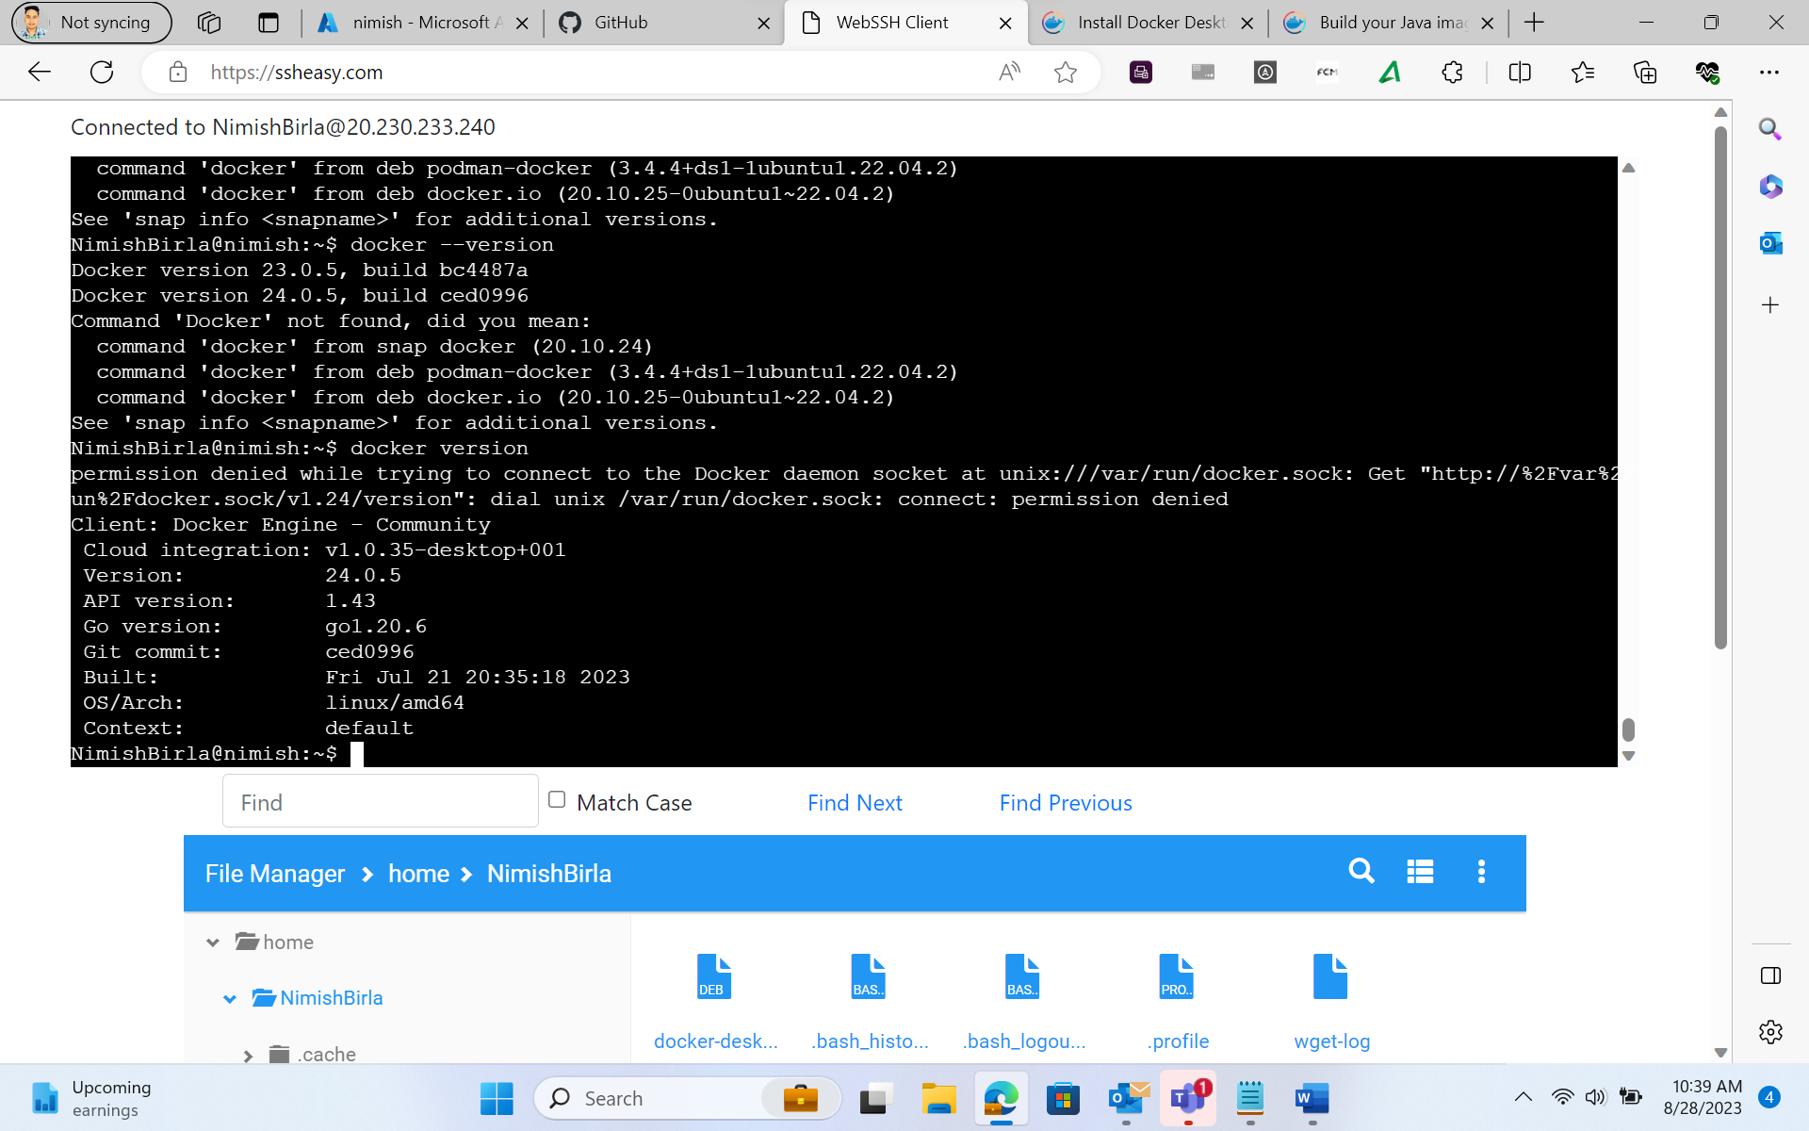

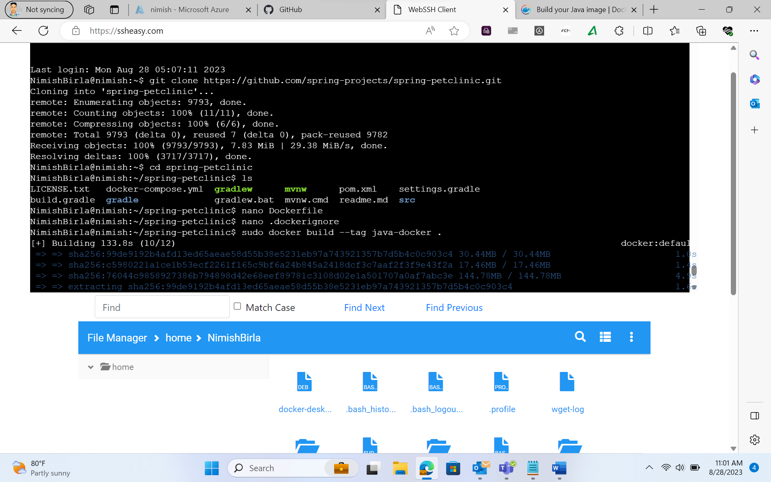

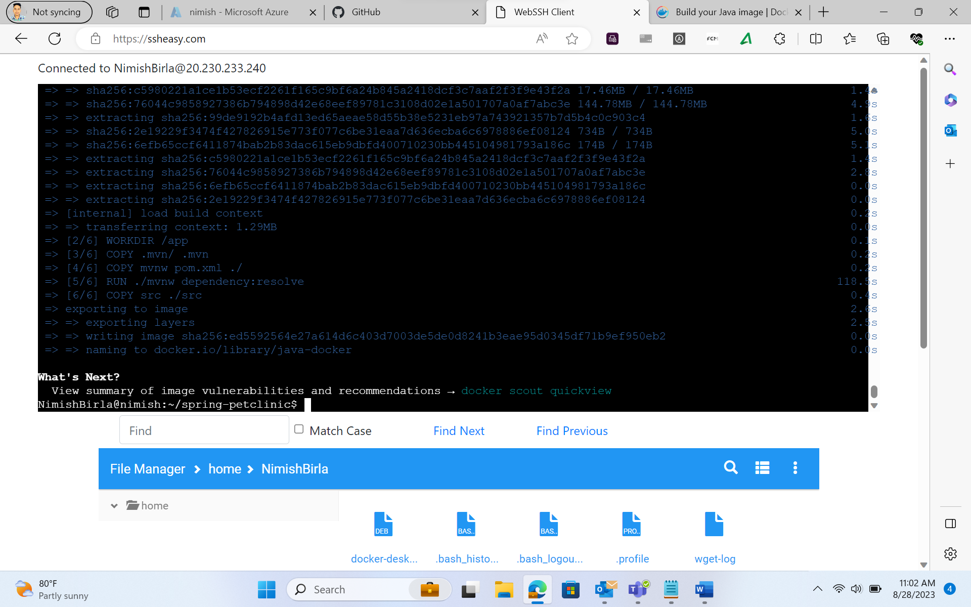

Azure Web App Configuration:

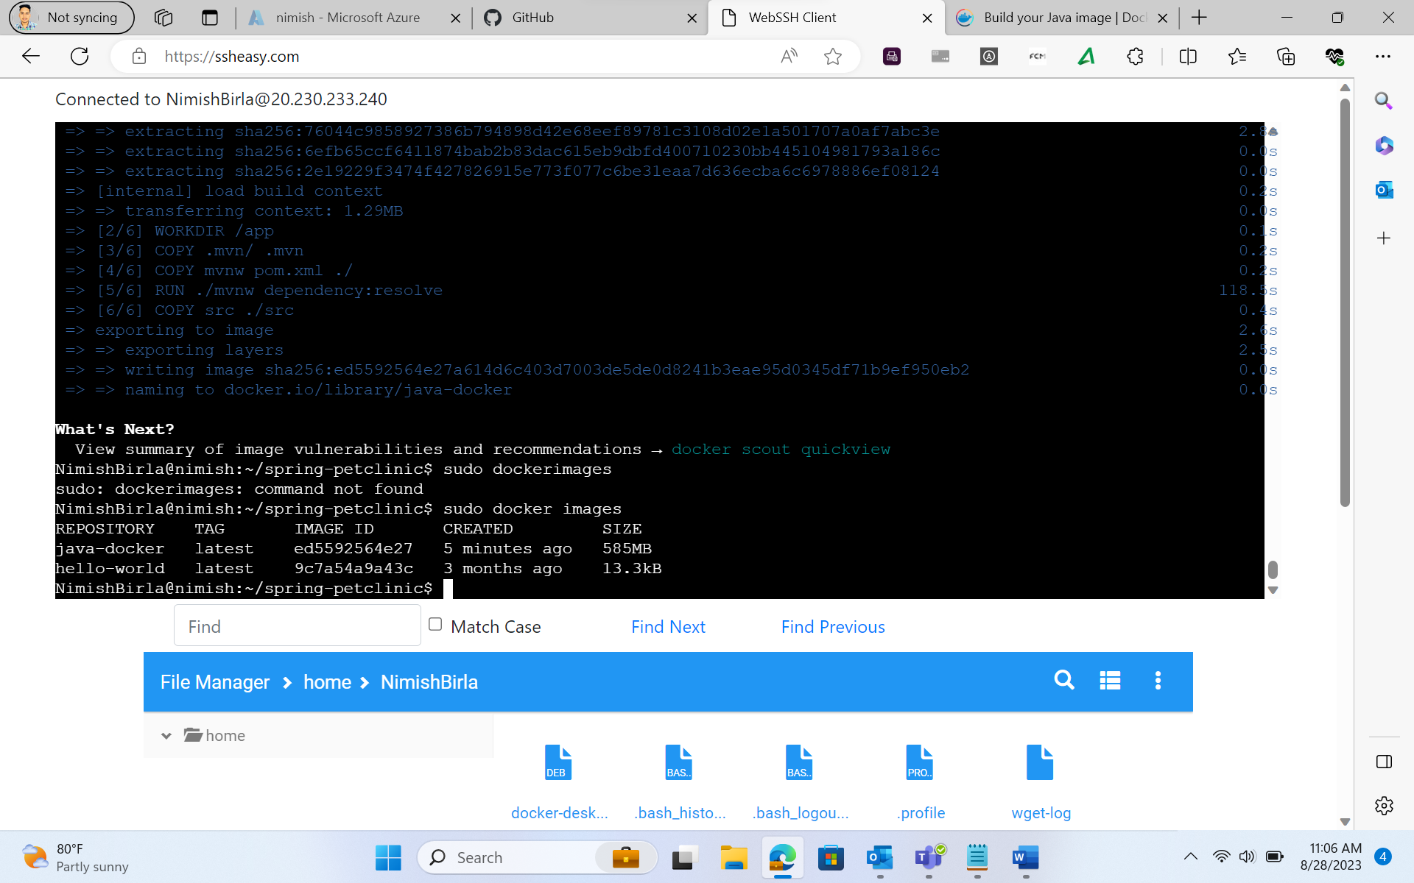

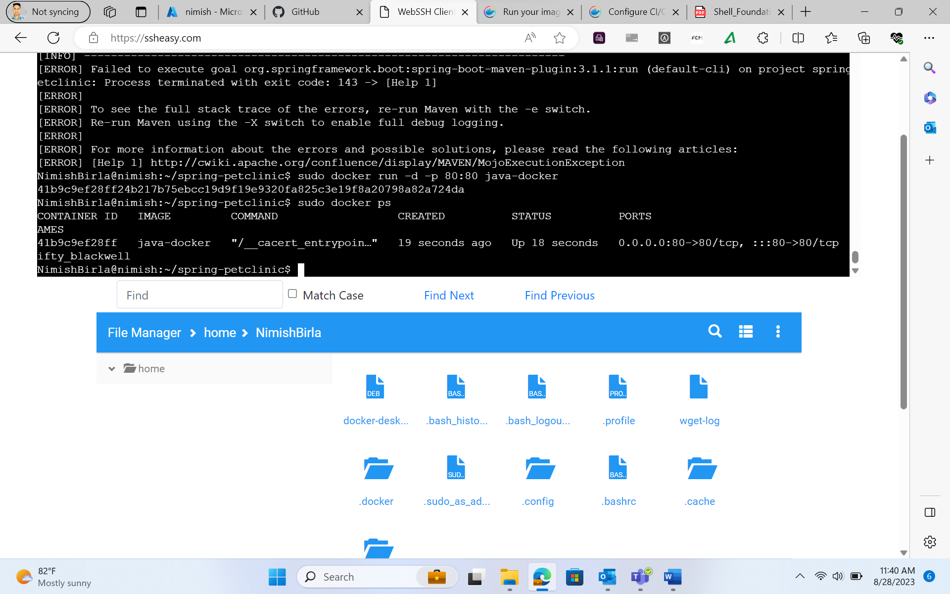

Pull Request Collaboration:

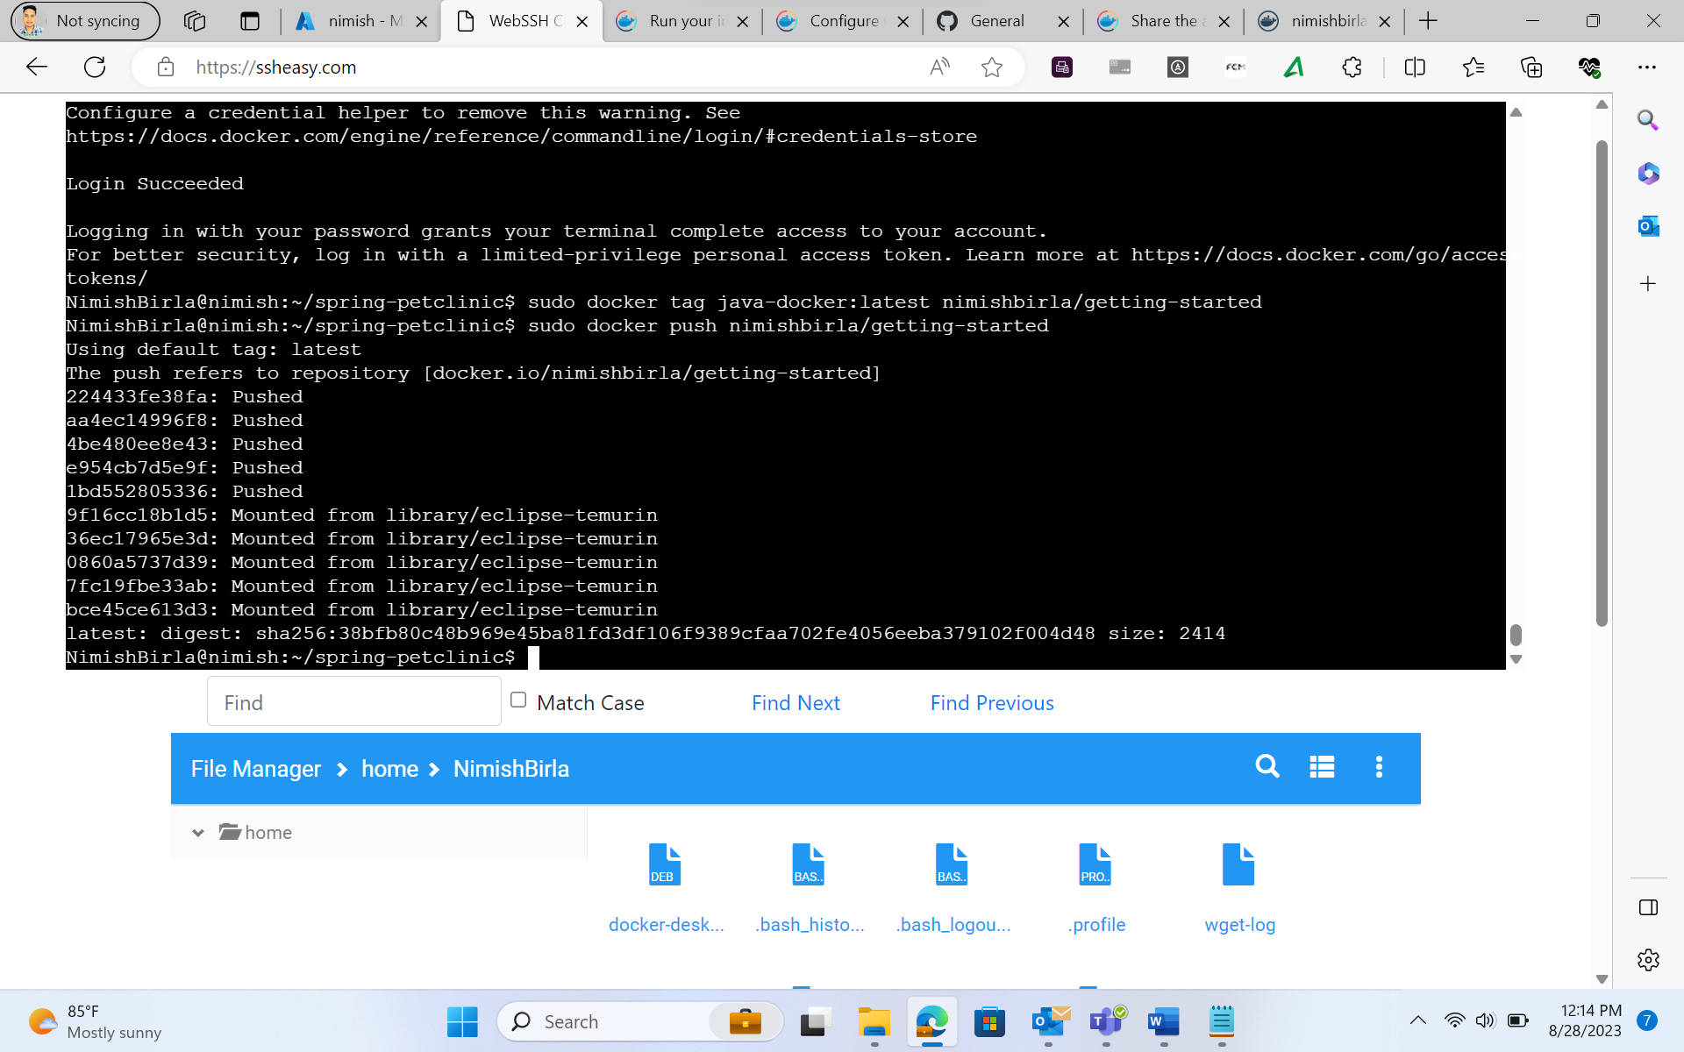

GitHub Actions Workflow Implementation:

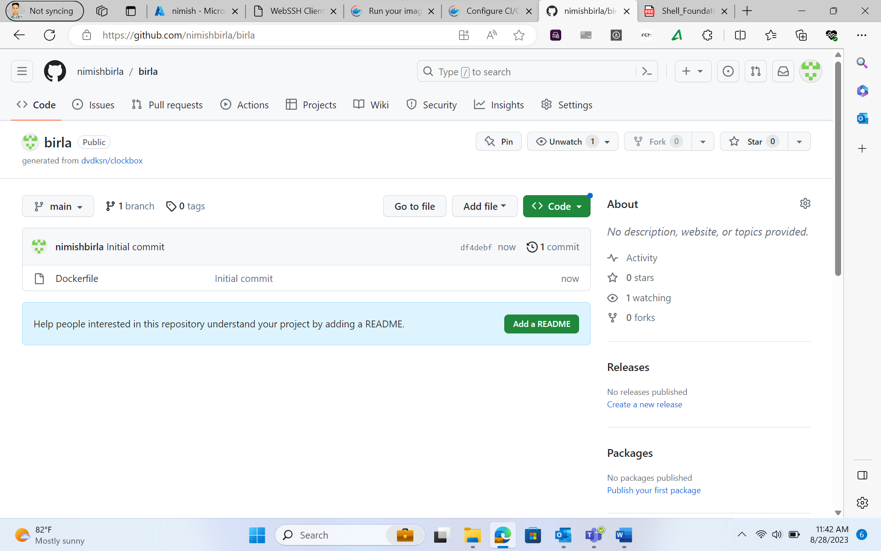

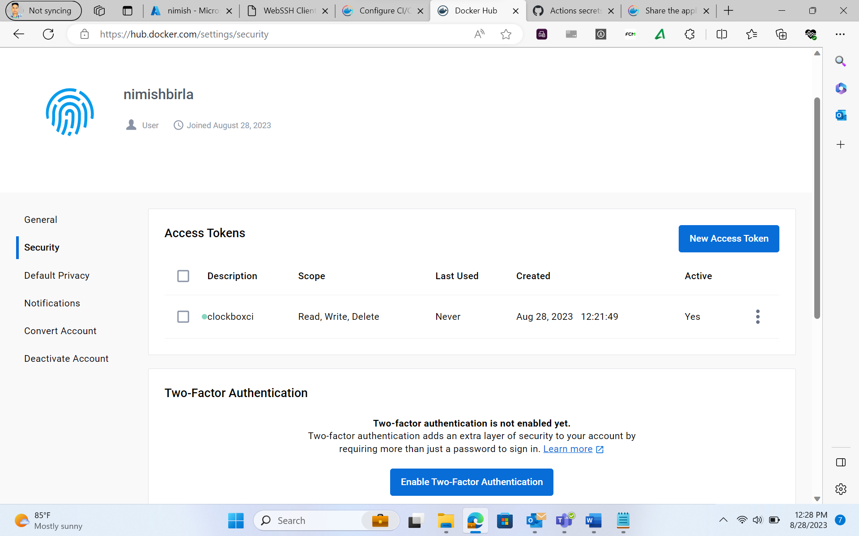

The main.yml file-

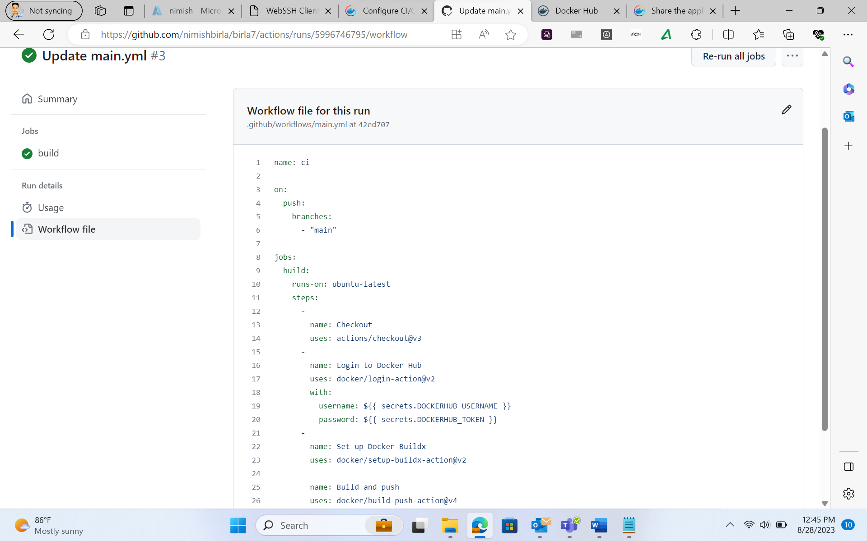

Successful build of the main.yml file-

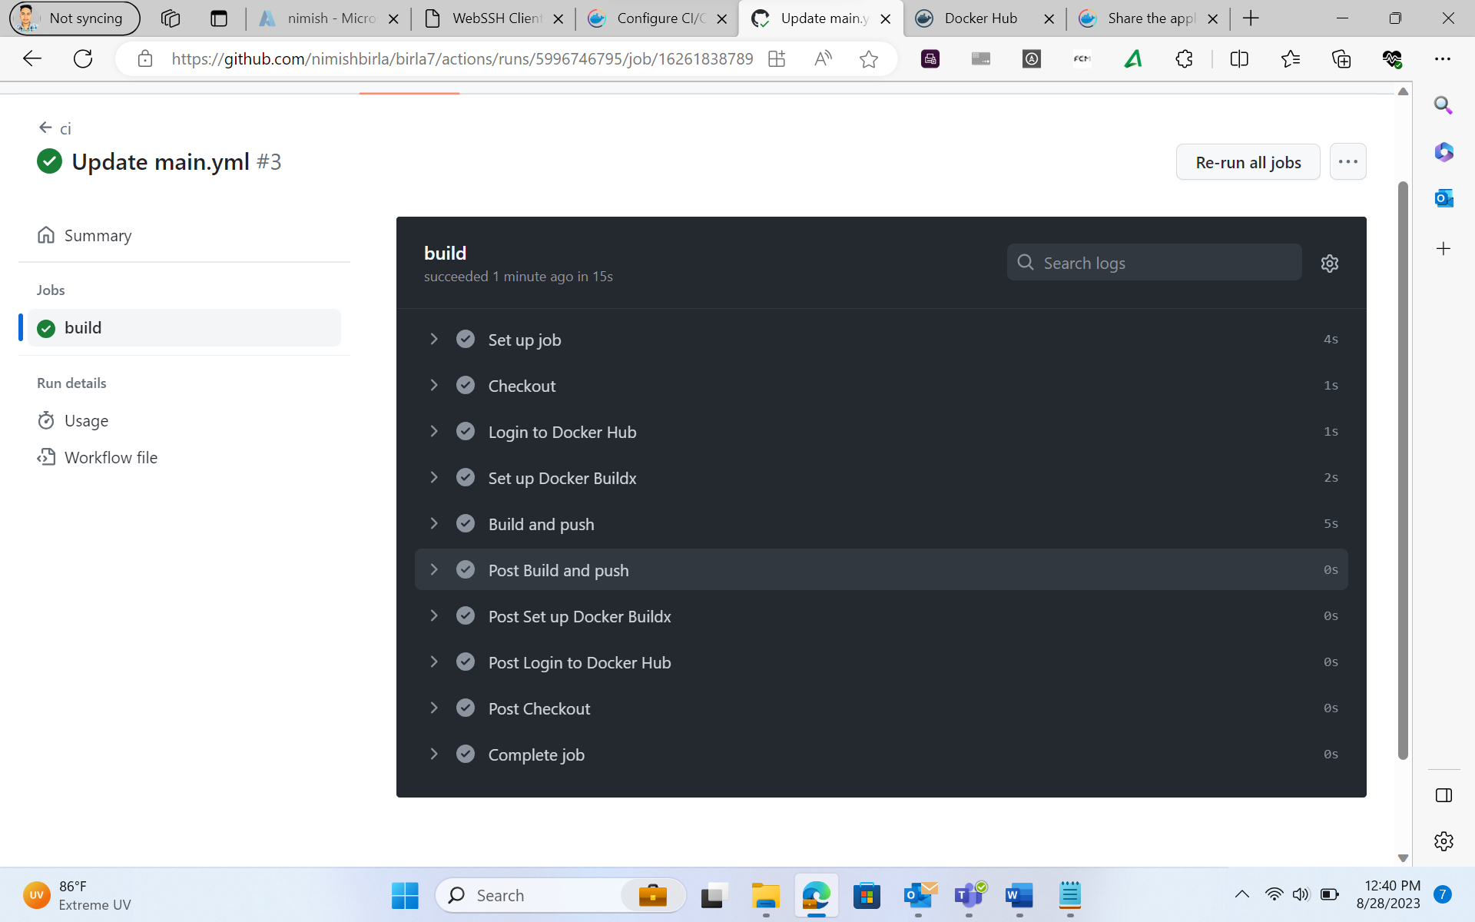

Local Testing of Azure Web App:

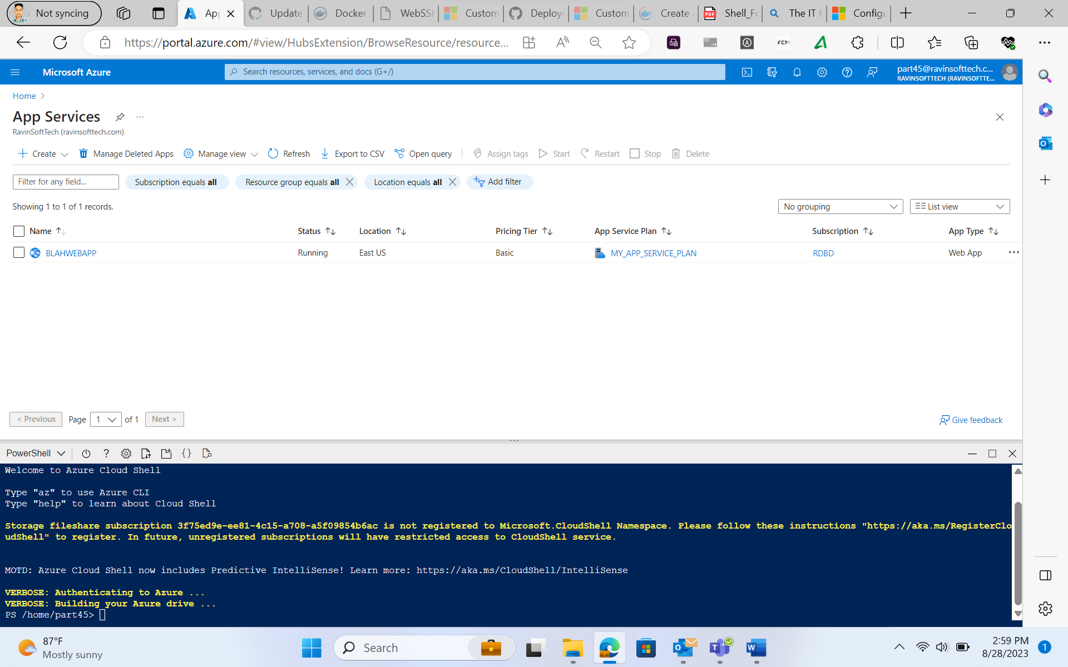

Azure Boards Task and Sprint Closure:

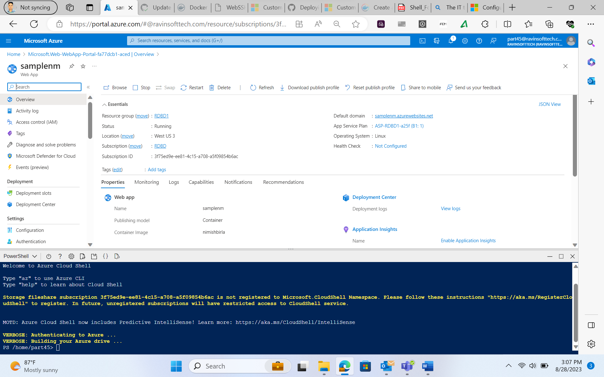

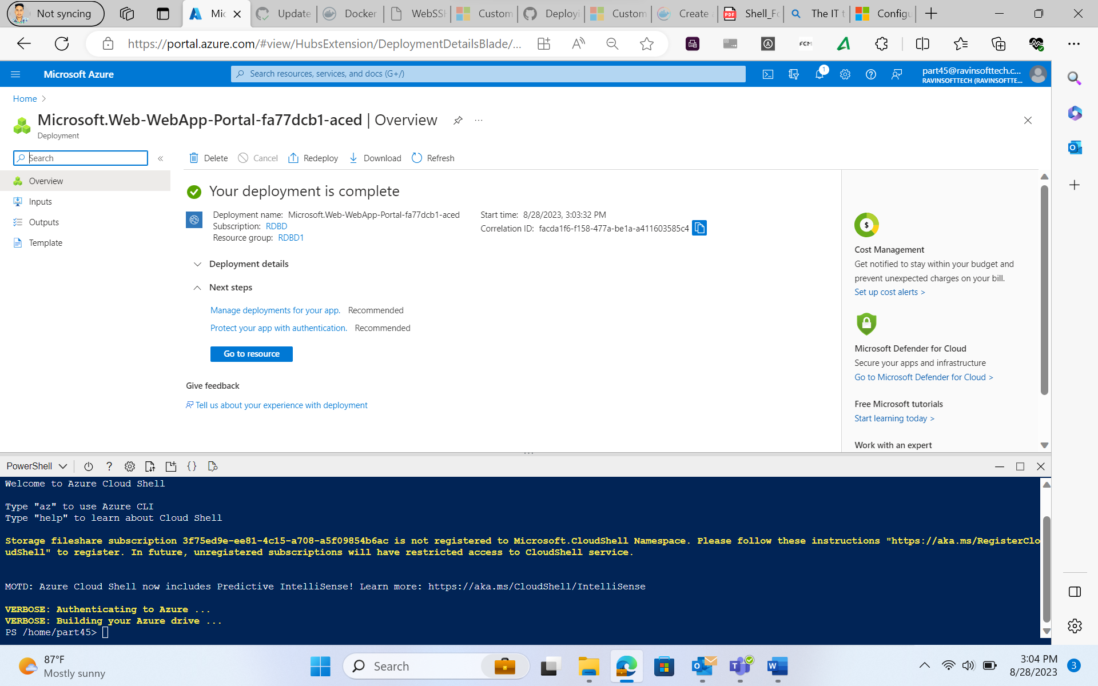

Outcome:

Commands-

1 cls  
2 clear  
3 sudo apt update  
4 sudo apt install git  
5 sudo apt install maven  
  
  
7 sudo apt update  
8 sudo apt-get install ca-certificates curl gnupg  
9 sudo install -m 0755 -d /etc/apt/keyrings  
10 curl -fsSL [https://download.docker.com/linux/ubuntu/gpg](https://eur02.safelinks.protection.outlook.com/?url=https%3A%2F%2Fdownload.docker.com%2Flinux%2Fubuntu%2Fgpg&data=05%7C01%7Cnimish.birla%40shell.com%7C1dfac7010d3a499c323408dba7b42977%7Cdb1e96a8a3da442a930b235cac24cd5c%7C0%7C0%7C638288164448414794%7CUnknown%7CTWFpbGZsb3d8eyJWIjoiMC4wLjAwMDAiLCJQIjoiV2luMzIiLCJBTiI6Ik1haWwiLCJXVCI6Mn0%3D%7C3000%7C%7C%7C&sdata=ol7t%2Bnqt82fcl8v%2BM9AAH0czCLiH3m8PLbNwQuqra9o%3D&reserved=0) | sudo gpg --dearmor -o /etc/apt/keyrings/docker.gpg  
11 sudo chmod a+r /etc/apt/keyrings/docker.gpg  
12 echo "deb [arch="$(dpkg --print-architecture)" signed-by=/etc/apt/keyrings/docker.gpg] [https://download.docker.com/linux/ubuntu](https://eur02.safelinks.protection.outlook.com/?url=https%3A%2F%2Fdownload.docker.com%2Flinux%2Fubuntu&data=05%7C01%7Cnimish.birla%40shell.com%7C1dfac7010d3a499c323408dba7b42977%7Cdb1e96a8a3da442a930b235cac24cd5c%7C0%7C0%7C638288164448414794%7CUnknown%7CTWFpbGZsb3d8eyJWIjoiMC4wLjAwMDAiLCJQIjoiV2luMzIiLCJBTiI6Ik1haWwiLCJXVCI6Mn0%3D%7C3000%7C%7C%7C&sdata=3LTJ6lT6pTINQqpnXyTuWCJ8F%2BISq6qJAvvMRRCPrqY%3D&reserved=0) \  
13 "$(. /etc/os-release && echo "$VERSION_CODENAME")" stable" | sudo tee /etc/apt/sources.list.d/docker.list > /dev/null  
14 sudo apt-get update  
15 sudo apt-get install docker-ce docker-ce-cli [containerd.io](https://eur02.safelinks.protection.outlook.com/?url=http%3A%2F%2Fcontainerd.io%2F&data=05%7C01%7Cnimish.birla%40shell.com%7C1dfac7010d3a499c323408dba7b42977%7Cdb1e96a8a3da442a930b235cac24cd5c%7C0%7C0%7C638288164448414794%7CUnknown%7CTWFpbGZsb3d8eyJWIjoiMC4wLjAwMDAiLCJQIjoiV2luMzIiLCJBTiI6Ik1haWwiLCJXVCI6Mn0%3D%7C3000%7C%7C%7C&sdata=%2F0IF%2F%2F9LHmu3SMdBxGiu9BQdd0834%2BGc6QaWB6j%2B7UY%3D&reserved=0) docker-buildx-plugin docker-compose-plugin  
16 sudo docker run hello-world  
17 systemctl status docker  
18 git clone [https://github.com/hrb1989/shell_7_foundation_Java_Spring.git](https://eur02.safelinks.protection.outlook.com/?url=https%3A%2F%2Fgithub.com%2Fhrb1989%2Fshell_7_foundation_Java_Spring.git&data=05%7C01%7Cnimish.birla%40shell.com%7C1dfac7010d3a499c323408dba7b42977%7Cdb1e96a8a3da442a930b235cac24cd5c%7C0%7C0%7C638288164448414794%7CUnknown%7CTWFpbGZsb3d8eyJWIjoiMC4wLjAwMDAiLCJQIjoiV2luMzIiLCJBTiI6Ik1haWwiLCJXVCI6Mn0%3D%7C3000%7C%7C%7C&sdata=4NiXVGsadFuEPVcd0VzRxYS%2BqvWRza8ypPr3bJXajHs%3D&reserved=0)  
19 cd shell_7_foundation_Java_Spring  
20 mvn install -DskipTests  
21 sudo apt install -y openjdk-17-jdk  
22 mvn install -DskipTests  
  
23* docker build -t <name> -f /home/azureuser/shell_7_foundation_Java_Spring/Dockerfile  
24 vi Dockerfile   
  
25 docker build --tag nimishbirla -docker:latest .  
26 sudo docker build --tag nimishbirla -docker:latest .  
27 sudo docker login  
28 sudo docker images  
29 sudo docker tag nimishbirla-docker:latest nimishbirla/nimishbirla-docker  
30 sudo docker push nimishbirla/nimishbirla-docker

